A Sample AAS Word File

Lihua WANG* [Insert footnote], and John SMITH²
¹Institute of Atmospheric Physics, Chinese Academy of Sciences, Beijing 100029, China
²International Pacific Research Center, University of Hawaii at Manoa Honolulu, Hawaii 96822, USA

ABSTRACT
A brief, concise abstract is required at the beginning of each manuscript. The abstract should summarize the principal conclusions arrived at in the paper and the methods used to reach them. The abstract should be 250 words or less in length. Unless absolutely essential, the abstract should contain no mathematical expressions and should refrain from including citations or footnotes, and should not use the first person. The text in the abstract and throughout the whole manuscript should be double-spaced.
Key words: 4–6 key words should be provided.
Article Highlights:
- 140 character limit including spaces
- 140 character limit including spaces
- 140 character limit including spaces
(Highlights are two to four result-oriented points that provide readers with an at-a-glance overview of the main findings of your article. Each Highlight must be less than 140 characters, including spaces, and the Highlights together must clearly convey only the results of the study. Ideas, concepts and methods are best saved for the abstract. )

1. Introduction
This document provides authors with the basic Advances in Atmospheric Sciences (AAS) formatting guidelines. The following sections outline the guidelines and formatting for text, figures, and tables using Microsoft Word. A more thorough review of all manuscript requirements can be found in the AAS Author Guide.
The length of the manuscript should be within 6000 words and there should be no more than 10 figures.

2. Text
The text (12-point, Times New Roman) should be set in one column and divided into sections, each with a separate heading and numbered consecutively using the following format.

2.1 Level 2 heading

2.1.1 Level 3 heading

2.1.1.1 Level 4 heading

2.2 Mathematical formulas and terms
Mathematical formulas can appear as display equations or in-line equations. Display equations are centered on their own line and are usually numbered, although this is not compulsory. In-line equations appear run-on in the text. Please ensure all symbols are defined in the text that follows and, when citing display equations, use Eq. (X), where X is the equation number.
When using Microsoft Word to prepare a manuscript, use MathType for display equations and other complicated mathematical expressions. Equation numbers should be given outside of MathType and surrounded by parentheses, such as (1). Throughout the paper, please ensure that all variables are set in italic font. If there are any vector or matrix/tensor quantities, these should be set in italic + bold font. Mathematical terms not set in italics (i.e. in roman font) include uppercase Greek letters, most mathematical functions (such as sin and ln), and most multiple-character quantities, e.g. relative humidity (RH). These quantities are set roman so that they will not appear to be products of variables (e.g. so that RH is not confused with R × H).
Similarly, subscripts that are words or abbreviations are normally set as roman, even when the variable with the subscript is set italic. Superscripts should be used to represent exponents or the transpose of a matrix. In all other cases, subscripts should be used. Two subscripts should be separated by a comma.

3. Figures and tables

3.1 Figures
Figures often pose tough problems for both editors and publishers. In this section, detailed instructions for preparing successful figures are provided. Please follow the steps below to produce acceptable figures that help facilitate a smooth publication process. A “Figures FAQs” is also provided (below), which gives answers to the most common problems relating to figures that occur during the publishing process. Most importantly, vector-based graphics (e.g. PS, PDF, Adobe Illustrator) are preferred. Each figure should be embedded in the body of the manuscript as close as possible to its citation following a paragraph or section (we understand this placement may not always be possible for authors using LaTeX).

3.1.1 Tips for authors when preparing figures
(1) Aim to produce your figures at 100% the publication size. Figures are adjusted into two sizes for the published product: one-column sizing at approximately 60–80 mm wide (Fig. 1); and two-column sizing at approximately 120–160 mm wide.
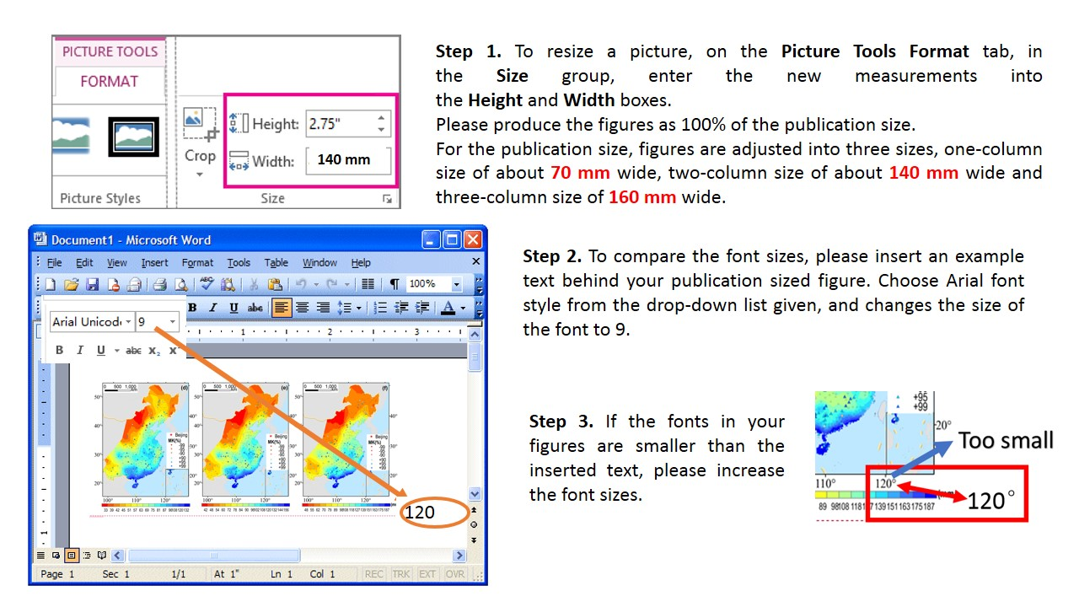
Fig. 1. Figures are adjusted into two sizes for the published product: one-column sizing at approximately 60–80 mm wide; and two-column sizing at approximately 120–160 mm wide.
(2) Ensure all annotation/labelling in your figures is readable in the fonts/font sizes you have used. The preferred font and size for figure labelling/annotation is Arial 9 pt. If other fonts are preferred/necessary, please choose them carefully and ensure that they are all embedded. If it is difficult for you to embed all the fonts, please convert them to paths (or outlines). For example, please create font outlines for figures drawn in Adobe Acrobat Illustrator to avoid them being transformed or removed (Fig. 2).
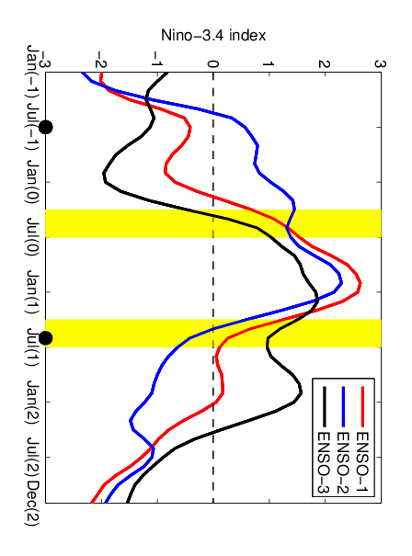
Fig. 2. Temporal evolution of the Niño3.4 index for three reference ENSO events (referred to as ENSO-1, ENSO-2, ENSO-3) modeled by the ICM. The colored curves denote the corresponding ENSO (refer to the legend in the top-right corner of the figure), which are chosen to be “true” states as comparisons with prediction experiments. The notation (−1) denotes the year before the ENSO event, (0) denotes the year of the ENSO onset phase, and (1) represents the following year. The spring season, when there is a sharp drop-off in the correlation between predictions and observations associated with ENSO, is represented by yellow bars. The times between the black points are the start months of predictions over the period from July(−1) to June(1), with a one-month interval.

(3) At 100% the publication size, the resolution for graphics files must be 300–600 dots-per-inch resolution (dpi) for color and gray-scale images, and at least 600 dpi for black and white line images. Please note that enlargement of figures will decrease the resolution. For example, a 400 dpi image scaled at 200% becomes 200 dpi (Fig. 3).
Fig. 3. Composited 200 hPa GH anomalies (units: gpm) 5–10 days prior to (a) minor SSWs and (d) major SSWs, derived from the NCEP–NCAR reanalysis dataset. The anomalies over dotted regions are statistically significant above the 99% confidence level according to the Student’s t-test. (b, e) Wavenumber-1 and (c, f) wavenumber-2 components of 200 hPa height anomalies preceding (b, c) minor SSWs and (e, f) major SSWs, shown by contours (contour intervals: ±10, ±20, ±30 gpm). The color-filled contours in (b, e) represent the climatology of wavenumber 1 and the color-filled contours in (c, f) represent the climatology of wavenumber 2.

(4) In almost all circumstances, the line thickness for lines, numbers, and words should be at least 0.2 pt. Otherwise, they may appear broken or disappear completely in the final publication. Please note that a reduction in figure size will make the line weight thinner. For example, a 1-pt line scaled at 50% becomes 0.5-pt (Fig. 4).

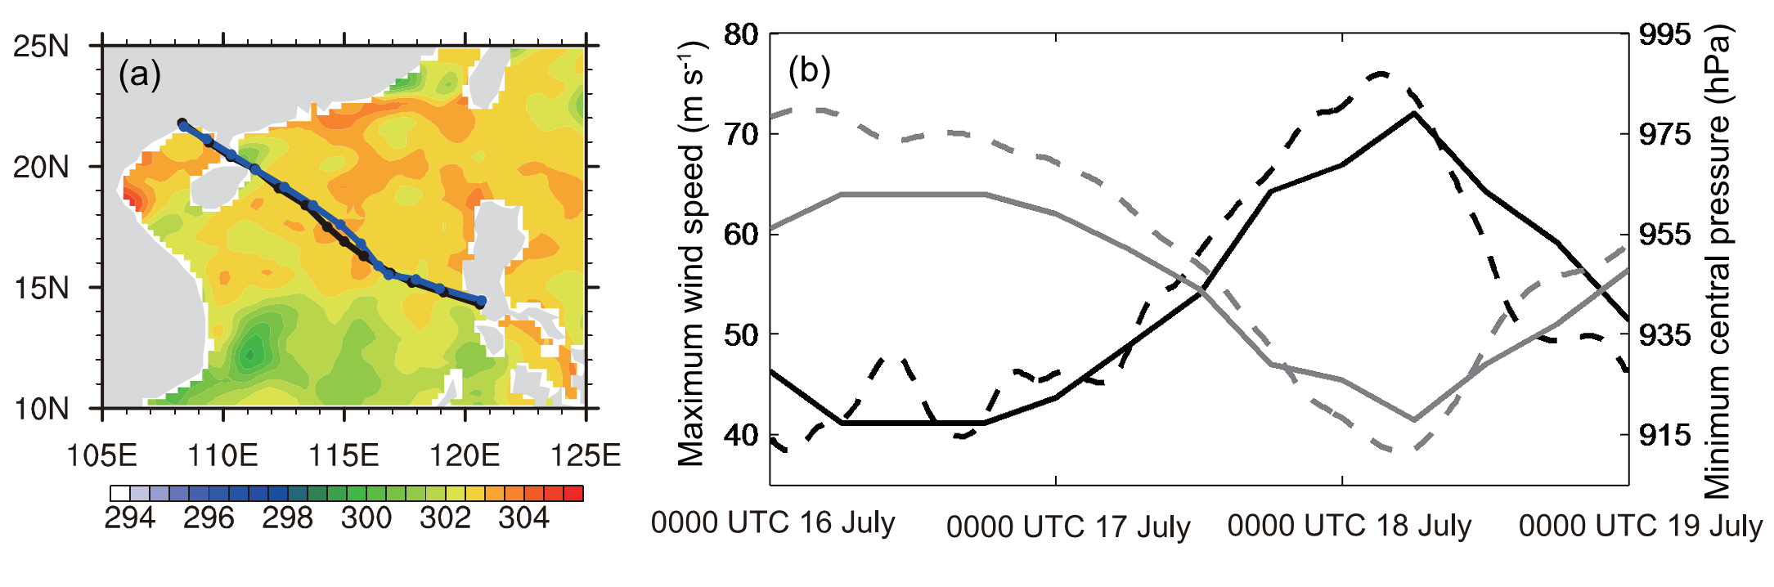
Fig. 4. (a) Observed (black) and simulated (blue) TC track and observed SST at 0000 UTC 16 July 2014. (b) Observed (solid) and simulated (dashed) TC intensity, in terms of maximum sustained 10-m wind speed (black; units: m s⁻¹) and central minimum sea level pressure (gray; units: hPa).

(5) Information that is clearly explained in the figure caption should not be repeated in the figure annotation. Please aim to make your figures both readable and concise.
(6) For axis titles, please only capitalize the first letter of the first word (unless subsequent words are proper nouns).
(7) It is better to denote combined units with a negative exponent than a solidus (forward-slash). Please also ensure there is a one-letter space between units with different symbols.
(8) For subfigures, lettered labels, i.e. (a), (b), (c) etc., should be positioned (preferably in the corners) in a way that does not obscure other parts of the figure, and the positioning should be consistent among all subfigures.
(9) For color figures, CMYK is required for the print version of the journal. Authors should clearly indicate which figures are intended to be published in color when submitting. For figures in color but not intended to be published in color, it is strongly recommended that you reproduce them in black and white to ensure good quality printing.

3.1.2 Figures FAQs
(1) Why is my figure labelling fuzzy or saw-toothed?
Figures are converted into .eps format before being adapted into our typesetting system. As .eps format is vector-based, for figures in pixel-based formats (e.g. .jpg, .bmp, .psd, .gif), after conversion, the quality will be greatly diminished and might appear fuzzy.
(2) Why is there a shadow in my figure?
Insertion of figures into word or PPT might create a shadow. Try providing us the figures in source format.
(3) Why should line thicknesses be at least 0.2 pt?
The print resolution is lower than the figure itself. The lines will appear broken instead of continuous in the final printed product for line thicknesses lower than 0.2pt.
(4) What is CMYK?
CMYK (cyan, magenta, yellow, black) figures are widely used for printing.
(5) Why do all the fonts need to be embedded or converted to paths or outlines?
It is recommended that all fonts are embedded when first created. If it is difficult to embed the fonts in the figure-drawing software, the alternative is to create outlines for the fonts used. In some cases, if the fonts are not embedded or created with outlines, they will be converted to a totally different font or become lost when converted to another format.

3.2 Tables
Tables should be numbered, have a caption (above the table), and mentioned specifically in the text (Table 1), captions should be double-spaced. Tables should be embedded in the body of the manuscript as close as possible to its citation following a paragraph or section break (we understand this placement may not always be possible for authors using LaTeX).

Table 1. This is a sample table caption and table layout. Enter as many tables as necessary at the end of your manuscript. Trend in the atmospheric heat source/sink E and its components over the CE-TP and W-TP, in units of W m⁻² (10 yr)⁻¹. The analysis period for SH and LH is 1980–2003, and for RC it is 1984–2004.
Region | Component | MAM | JJA | SON | DJF | Annual
SE-TP | SH | −5.4 | −3.1 | −2.6 | −2.3 | −3.4
 | LH | 1.5 | 0.5 | 0.4 | 0.3 | 0.7
 | RC | −8.1 | −9.7 | −14.4 | −12.7 | −11.2
 | E | −12.0 | −12.3 | −16.6 | −14.7 | −13.9
W-TP | SH | −3.0 | −6.1 | 0.2 | 1.1 | −2.0
 | LH | −1.4 | 1.3 | −1.6 | 0.4 | 0.3
 | RC | 4.5 | −3.6 | −7.0 | −1.4 | −1.8
 | E | 0.1 | −8.4 | −8.4 | 0.1 | −4.2

4. Citations and references
Following the guidelines for citations and references can expedite the time taken to process your manuscript.

4.1 Instructions for citations
Citations to standard references in the text should consist of the name of the author and the year of publication—for example, Wang (1990) or (Wang, 1990). If there are three or more authors, state the first author’s surname, followed by "et al." and the year of publication—for example, Wang et al. (1990) or (Wang et al., 1990). When there are two or more papers by the same author or authors in the same year, distinguishing letters (a, b, c, etc.) should be added to the year in both the citation in the text and the reference listing—for example, Wang (1990a). For multiple citations by one author, separate years by commas—for example, Wang (1989, 1990) or (Wang, 1989, 1990). Separate multiple citations by different authors within the same parentheses by semicolons—for example, (Wang, 1990; Li, 1991) or (Wang, 1989, 1990; Li, 1991).

4.2 Instructions for references
References should be listed alphabetically, without numbering, at the end of the paper. References must be complete and properly formatted, and only literature cited in the text should be listed.
(1) Journal papers:
Author(s), publication year: Article title. Journal name, volume, page range.
For example,
Boville, B. A., and J. W. Hurrell, 1998: A comparison of the atmospheric circulations simulated by the CCM3 and CSM1. J. Climate, 11, 1327–1341.
(2) Books:
Author(s), publication year: Book Title. Publisher, total pages.
For example,
Pedlosky, J., 1987: Geophysical Fluid Dynamics. 2nd ed., Springer-Verlag, 710pp.
(3) formbook chapters:
Author(s), publication year: chapter title. Book Title, Editor(s), Publisher, page range.
For example,
Zhang, R. H., and J. P. Chao, 1993: Mechanisms of interannual variations in a simple air-sea coupled model in the tropics. Climate Variability, D. H. Ye, et al., Eds., China Meteorological Press, Beijing, 236–244.
(4) Multi-volume book chapters:
Author(s), publication year: chapter title. Book Title, Editor(s), Volume No., Publisher, page range.
Tukey, J. W., 1993: The problem of multiple comparisons. Multiple Comparisons: 1948–1983, H. I. Braun, Ed., Vol. VIII, The Collected Works of John W. Tukey, Chapman Hall, 1–300.
(4) Other examples:
Presentation at a conference:
Lhermitte, R., and M. Gilet, 1976: Acquisition and processing of tri-Doppler radar data.
Preprints, 17th Conf. on Radar Meteorology, Seattle, WA, Amer. Meteor. Soc., 1–6.
Technical report:
Rogers, D. P., and Coauthors, 2005: THORPEX International Research Implementation Plan. WMO/TD-No. 1258, 96pp.
Acknowledgments. Keep the acknowledgements section as brief as possible by acknowledging only direct assistance in your research and writing. Financial support for the work should be acknowledged here rather than as footnotes to the title.
References
Duan, A. M., G. X. Wu, Y. M. Liu, Y. M. Ma, and P. Zhao, 2012: Weather and climate effects of the Tibetan Plateau. Adv. Atmos. Sci., 29(5), 978–992, doi: 10.1007/s00376-012-1220-y.
Hamilton, K., 2006: High resolution global modeling of the atmospheric circulation. Adv. Atmos. Sci., 23(6), 842–856
Lhermitte, R., and M. Gilet, 1976: Acquisition and processing of tri-Doppler radar data. Preprints, 17th Conf. on Radar Meteorology, Seattle, WA, Amer. Meteor. Soc., 1–6.
Meixner, T., L. A. Bastidas, H. V. Gupta, and R. C. Bales, 2002: Multicriteria parameter estimation of models of stream chemical composition. Water Resour. Res., 38, 1027, doi: 10.1029/2000WR000112.
NWS, 1999: A Vision for the National Weather Service: Road Map for the Future. National Academy of Sciences, NAS Press, Washington D. C., 75pp.
Pedlosky, J., 1987: Geophysical Fluid Dynamics. 2nd ed., Springer-Verlag, 710pp.
Rogers, D. P., and Coauthors, 2005: THORPEX International Research Implementation Plan. WMO/TD-No. 1258, 96pp.
Tukey, J. W., 1993: The problem of multiple comparisons. Multiple Comparisons: 1948–1983, H. I. Braun, Ed., Vol. VIII, The Collected Works of John W. Tukey, Chapman Hall, 1–300.
Yan, H. M., C. Y. Li, and W. Zhou, 2009: Influence of subtropical dipole pattern in southern Indian Ocean on ENSO event. Chinese Journal of Geophysics, 52(10), 2436–2449. (in Chinese)
Zhang, R. H, and J. P. Chao, 1993: Mechanisms of interannual variations in a simple air-sea coupled model in the tropics. Climate Variability, D. Z. Ye, et al., Eds., China Meteorological Press, Beijing, 236–244.
Zhou N. F., Y. Q. Yu, and Y.F. Qian, 2006: Simulations of the 100 hPa South Asia High and Precipitation over the East Asia with IPCC Coupled GCMs. Adv. Atmos. Sci., 23 (3), 375–390.

*Corresponding author : Lihua WANG Email: aas@mail.iap.ac.cn

